

**HofTAPS**

**Online Textbook Exchange**

**Product Requirements Specification**

**Table of Contents**

**Cover Page..…………………………………………………………………………………………………………1**

**Table of Contents…………………………………………………………………………………………………...2**

**1. Introduction……………………………………………………………………………………………………….7**

1.1 Project Scope…………………………………………………………………………………………..7

1.1.1 Account Registration………………………………………………………………………7

1.1.2 Add Textbooks to be Sold………………………………………………………………...7

1.1.3 Search Engine……………………………………………………………………………..7

1.1.4 Automatic Textbook Removal…………………………………………………………….7

1.1.5 Automatic Email Communication………………………………………………………...7

1.2 Use……………………………………………………………………………………………………...7

1.3 Technology Use………………………………………………………………………………………..8

1.3.1 Front End…………………………………………………………………………………...8

1.3.2 Back End……………………………………………………………………………………8

1.3.3 API…………………………………………………………………………………………..8

1.4 UI Design……………………………………………………………………………………………….8

1.4.1 Home………………………………………………………………………………………..8

1.4.2 Account……………………………………………………………………………………..9

1.4.3 Account History…………………………………………………………………………….9

1.4.4 Notifications……………………………………………………………………………….10

1.4.5 Wishlist…………………………………………………………………………………….10

1.4.6 Listings……………………………………………………………………………………..11

1.4.7 Individual Listings…………………………………………………………………………11

1.4.8 Sell Your Book…………………………………………………………………………….12

1.4.9 Settings…………………………………………………………………………………….12

1.4.10 Create Account………………………………………………………………………….13

1.4.11 Create Account Verification…………………………………………………………….13

1.4.12 User Profile………………………………………………………………………………14

**2. Product Description……………………………………………………………………………………………14**

2.1 Description…………………………………………………………………………………………….14

2.2 Features……………………………………………………………………………………………….15

2.2.1 Search and Filters………………………………………………………………………...15

2.2.2 Wishlist…………………………………………………………………………………….15

2.2.3 Notifications……………………………………………………………………………….15

2.2.4 Textbook Carousel………………………………………………………………………..15

2.2.5 User Ratings………………………………………………………………………………15

2.3 Operating Environment………………………………………………………………………………15

2.4 Design………………………………………………………………………………………………….16

2.5 Constraints and Challenges…………………………………………………………………………16

**3. System Features………………………………………………………………………………………………..16**

3.1 Main Page……………………………………………………………………………………………..16

3.1.1 Search Bar………………………………………………………………………………...16

3.1.1.1 Search by Subject…………………………………………………………….16

3.1.1.2 Search by Condition………………………………………………………….17

3.1.1.3 Search by Price……………………………………………………………….17

3.1.2 Sell Button………………………………………………………………………………....17

3.1.3 Featured Items…………………………………………………………………………....17

3.1.4 Left Bar…………………………………………………………………………………….17

3.1.4.1 Account Button………………………………………………………………..17

3.1.4.2 Notifications……………………………………………………………………17

3.1.4.3 Wishlist…………………………………………………………………………18

3.1.4.4 Listings…………………………………………………………………………18

3.1.4.5 Sell Your Book…………………………………………………………………18

3.1.4.6 Settings………………………………………………………………………...18

3.1.4.7 Help Center……………………………………………………………………18

3.1.5 Contact Information………………………………………………………………………18

3.2 Listing Page…………………………………………………………………………………….……..18

3.2.1 Search Bar………………………………………………………………………….……..18

3.2.2 Left Bar…………………………………………………………………………….………18

3.2.3 Filters……………………………………………………………………………….……...18

3.2.3.1 Subject……………………………………………………………….………...19

3.2.3.2 Price Slider………………………………………………….…………………19

3.2.3.3 Condition……………………………………………………….………………19

3.2.4 Sort………………………………………………………………………….……………...19

3.2.5 Individual Listings on Listing Page……………………………………………………...19

3.3 Selling Page…………………………………………………………………………………………..19

3.3.1 Fields……………………………………………………………………………………….19

3.3.2 Image Uploads……………………………………………………………………………20

3.3.3 Publish……………………………………………………………………………………..20

3.4 Individual Product Information………………………………………………………………………20

3.4.1 Layout……………………………………………………………………………………...20

3.4.2 Contact Seller……………………………………………………………………………..20

3.5 Purchasing…………………………………………………………………………………………….20

3.5.1 Contact Between Buyer and Seller……………………………………………………..20

3.5.2 Completed Deals………………………………………………………………………….20

3.5.3 Deals that Fall Through…………………………………………………………………..21

3.5.4 Database Updates………………………………………………………………………..21

3.6 Accounts……………………………………………………………………………………………….21

3.6.1 Authentication……………………………………………………………………………..21

3.6.2 Registration and Login…………………………………………………………………...21

3.6.3 Change Password………………………………………………………………………..21

3.6.4 Account Details……………………………………………………………………………21

3.6.4.1 Personal Information………………………………………………………….21

3.6.4.2 Account Management………………………………………………………..22

3.6.4.3 Notification Settings………………………………………..…………………22

3.6.4.4 My Listings………………………………………………………..…………...22

3.6.4.5 Items Sold………………………………………………………...……………22

3.6.5 Ratings…………………………………………………………………………..………...22

3.7 Notifications…………………………………………………………………………….….………….22

3.8 Help Center……………………………………………………………………………….…………..22

3.8.1 Getting Started…………………………………………………………….……………...22

3.8.2 Contact Support…………………………………………………………………………..22

3.9 Searching……………………………………………………………………………………………...22

3.9.1 Search Engine…………………………………………………………………………….22

3.9.2 Natural Language Processing…………………………………………………………..23

**4. Interface Requirements……………………………………………………………………………………….23**

4.1 Live Updating………………………………………………………………………………………….23

4.2 Page Responsiveness……………………………………………………………………………….23

4.2.1 Fluid Grid Layout………………………………………………………………………….23

4.2.2 Breakpoints………………………………………………………………………………..23

4.2.3 Content Prioritization……………………………………………………………………..23

4.3 Categories and Search Filters………………………………………………………………………23

4.4 Notifications…………………………………………………………………………………………...24

**5. Non-Functional Requirements……………………………………………………………………………….24**

5.1 Efficiency………………………………………………………………………………………………24

5.1.1 Item Search Time…………………………………………………………………………24

5.1.2 Use Database……………………………………………………………………………..24

5.1.3 Page Loading Time……………………………………………………………………….24

5.1.4 Search Filters……………………………………………………………………………..24

5.1.5 API Retrieval………………………………………………………………………………24

5.2 Usability………………………………………………………………………………………………..24

5.2.1 User Interaction with the Website……………………………………………………….24

5.2.2 Cross-Platform…………………………………………………………………………….24

5.3 Space…………………………………………………………………………………………………..25

5.4 Dependability………………………………………………………………………………………….25

5.4.1 Error Handling…………………………………………………………………………….25

5.4.2 Website Runtime………………………………………………………………………….25

5.5 Security………………………………………………………………………………………………..25

5.5.1 Password Encryption……………………………………………………………………..25

5.5.2 Notification Encryption……………………………………………………………………25

5.5.3 User Encryption…………………………………………………………………………...25

5.5.4 Captcha…………………………………………………………………………………....25

5.6 Maintainability…………………………………………………………………………………………25

5.6.1 Code Quality………………………………………………………………………………25

5.6.2 Scalability………………………………………………………………………………….26

5.7 Data Accuracy………………………………………………………………………………………...26

**6. Conclusion………………………………………………………………………………………………………26**

**1. Introduction**

**1.1 Project Scope**

It is often a hassle for college students to find and purchase a textbook for class. After going through all this work purchasing textbooks, students then end each semester with books they no longer need, which they may have spent hundreds of dollars on. HofTAPS aims to create a quick and easy way for Hofstra students to sell their old textbooks to other Hofstra students who need one for a class. HofTAPS allows Hofstra students to sell their old textbooks to other Hofstra students. This requires:

1.1.1 Account Registration: Hofstra students enter their student ID, number, Hofstra, email,

and a password

1.1.2 Add Textbooks to be Sold: Students can add a textbook by including the book’s title,

author, ISBN number, the condition of the book, a price they wish to sell it for, and any other information they wish to list.

1.1.3 Search Engine: A way for interested students to search and browse for textbooks using

title, author and ISBN number.

1.1.4 Automatic Textbook Removal: Once a textbook is sold, it is automatically removed from

the database

1.1.5 Automatic Email Communication: If a buyer is interested, an email is sent to the buyer to

initiate the sale. A sale confirmation email is sent to the buyer notifying them that the sale has been approved.

**1.2 Use**

The purpose of the textbook exchange software is to allow Hofstra students to easily buy and sell textbooks. Students who have a textbook that they no longer need list the book by entering the book’s title, author, ISBN number, the condition of the book, and the price they wish to sell it for. Other students who wish to purchase a textbook can search for a desired textbook by these specifications, see results, and make a purchase.

**1.3 Technology Use**

1.3.1 Front End: React is used to create a simple, clean, user-friendly experience

1.3.2 Back End: Firebase allows for all user and textbook information to be stored and allows

for easy access. Java allows for easy integration with the Amazon API and our front end frameworks.

1.3.3 API: Amazon’s API allows for information about each textbook to be gathered and shared

to allow users of the site to see all the information they may need about a particular textbook, including title, authors, and cover image.

**1.4 UI Design**

1.4.1 Home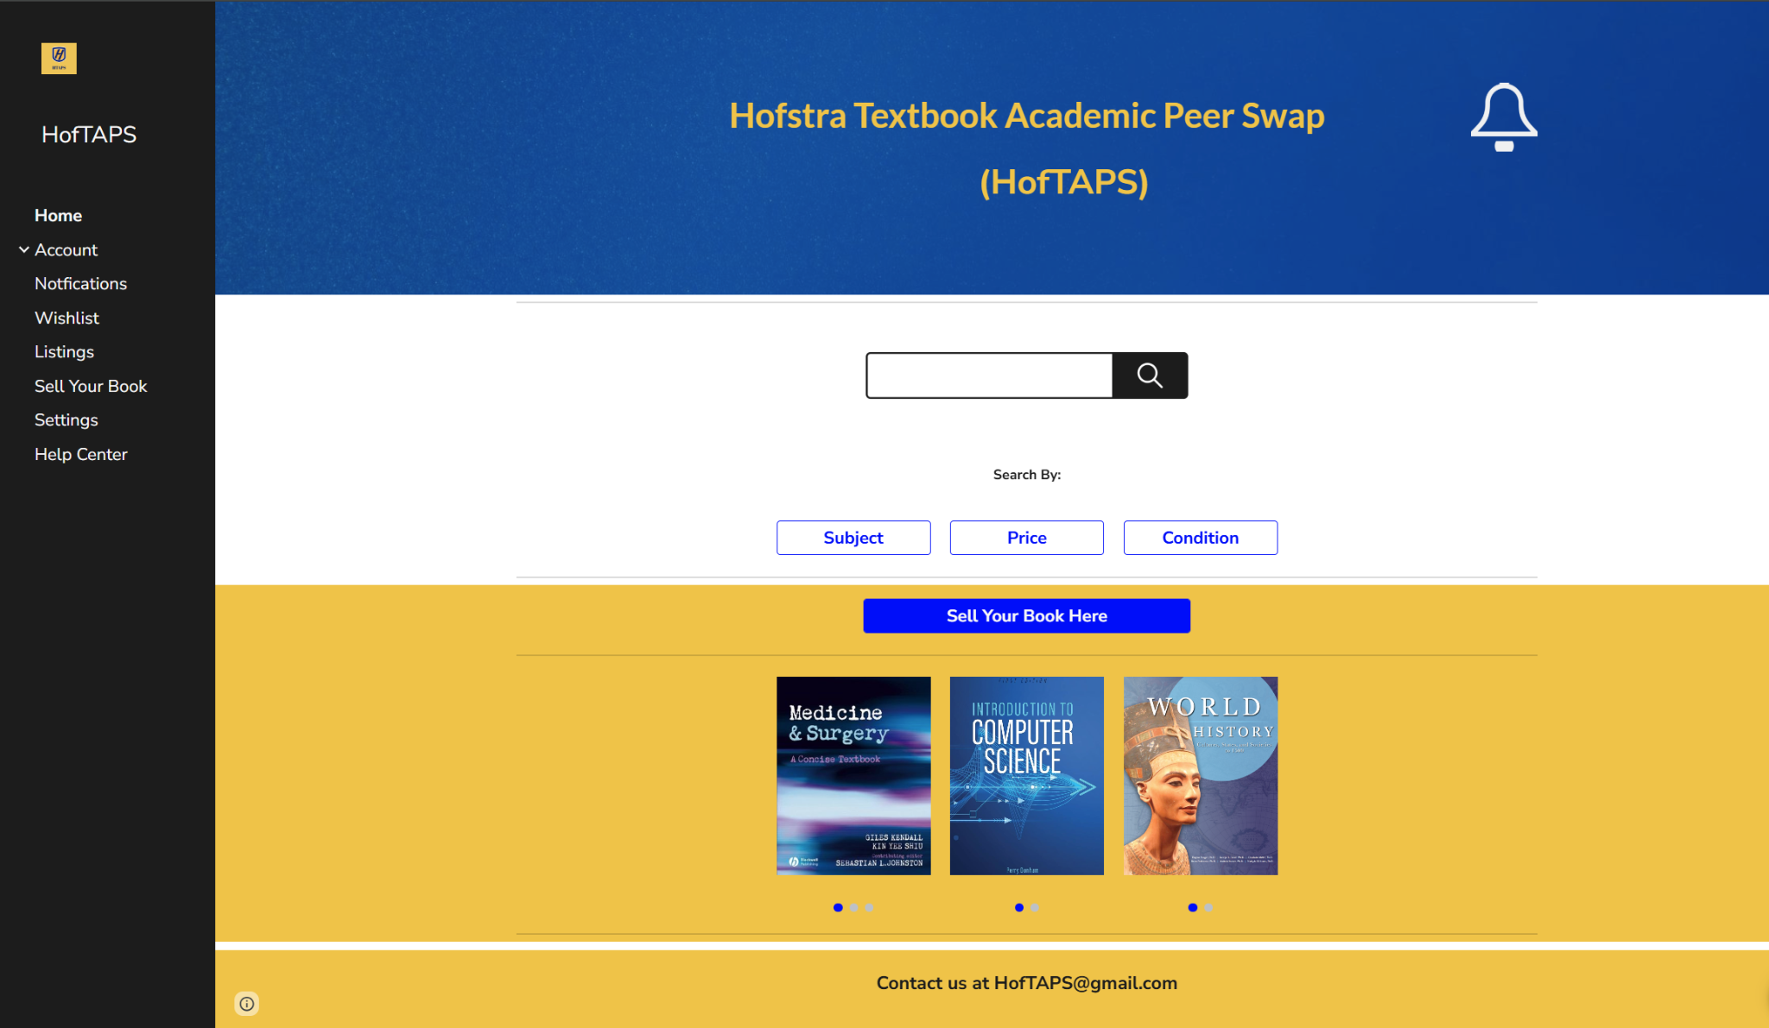

1.4.2 Account

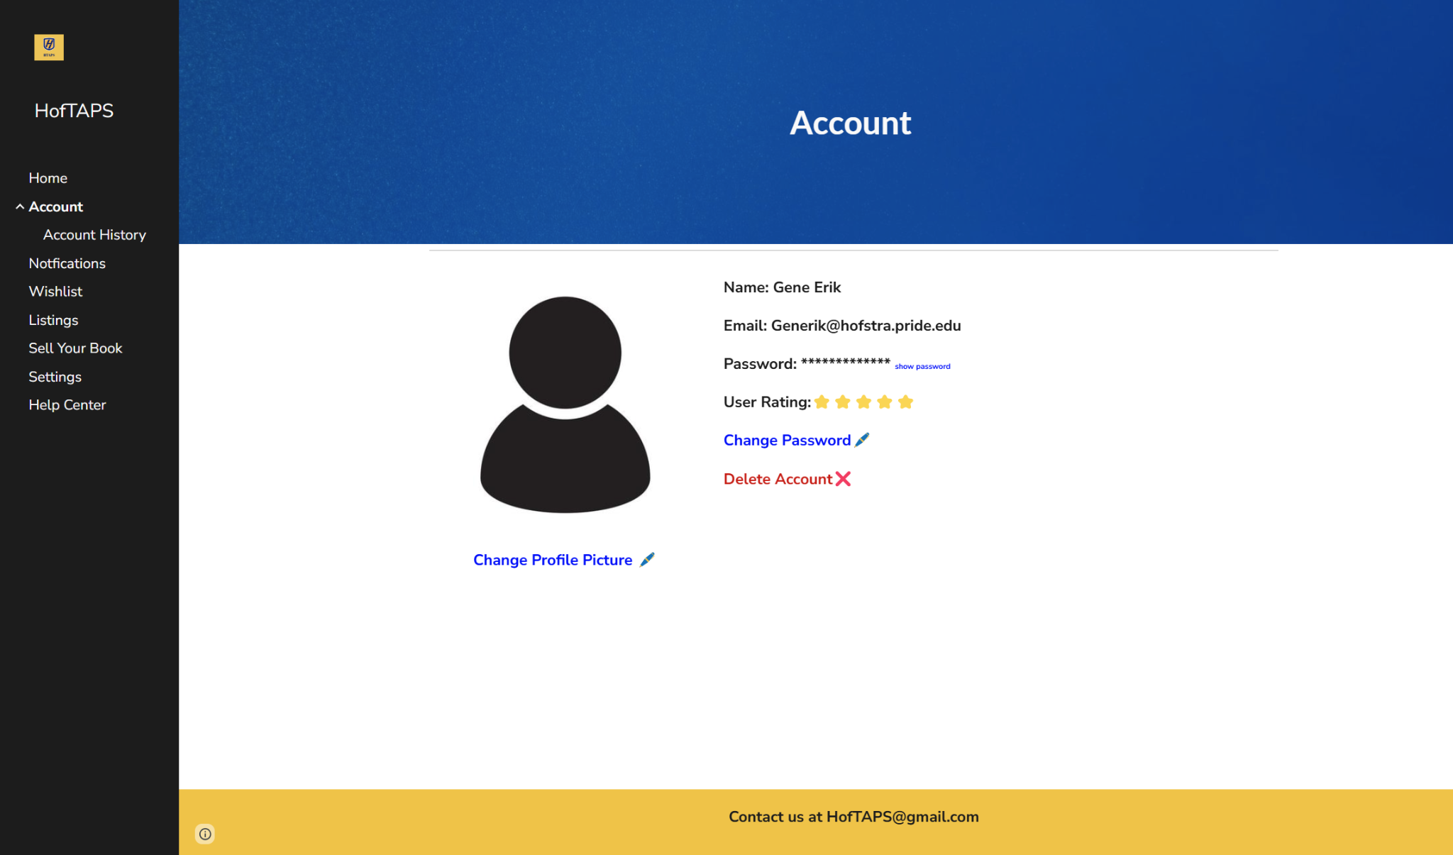

1.4.3 Account History

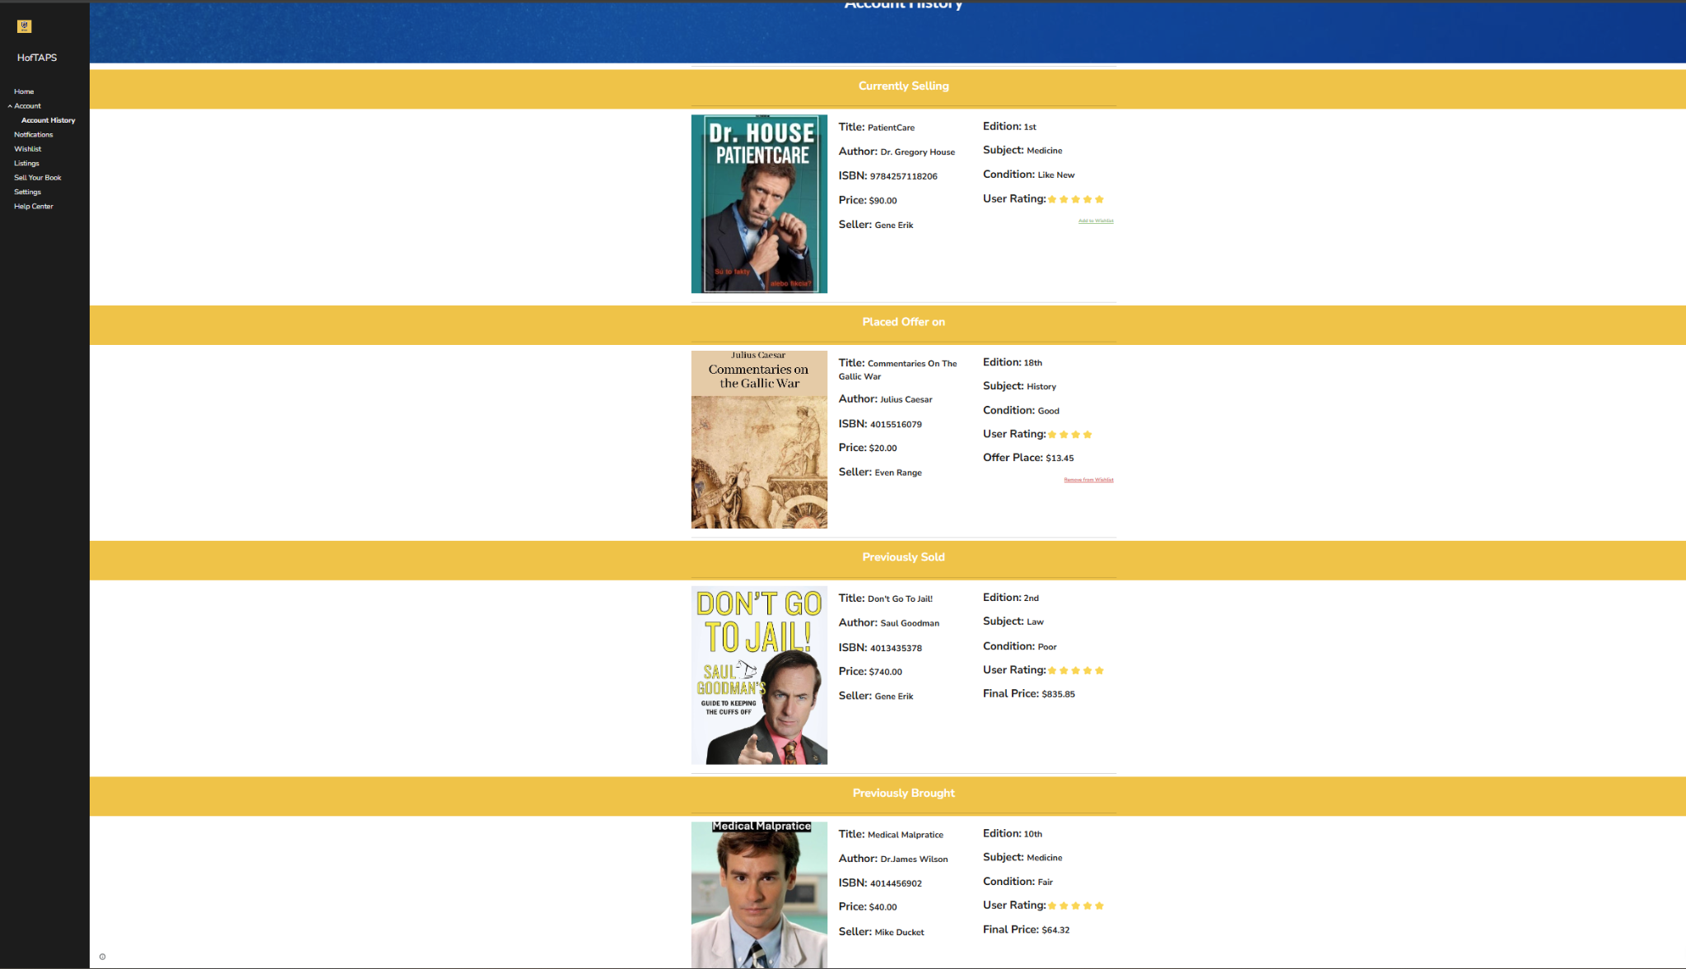

1.4.4 Notifications

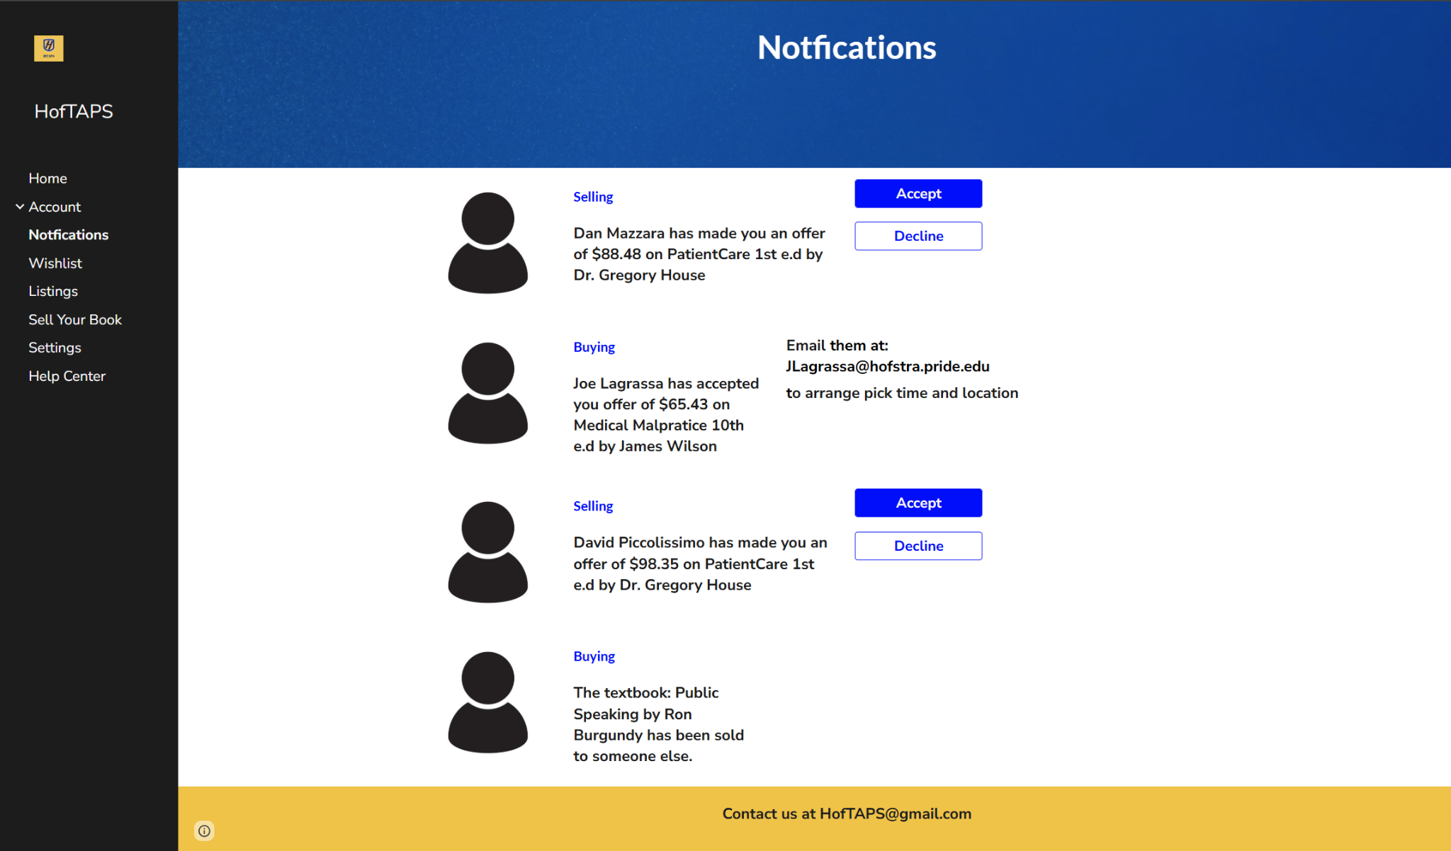

1.4.5 Wishlist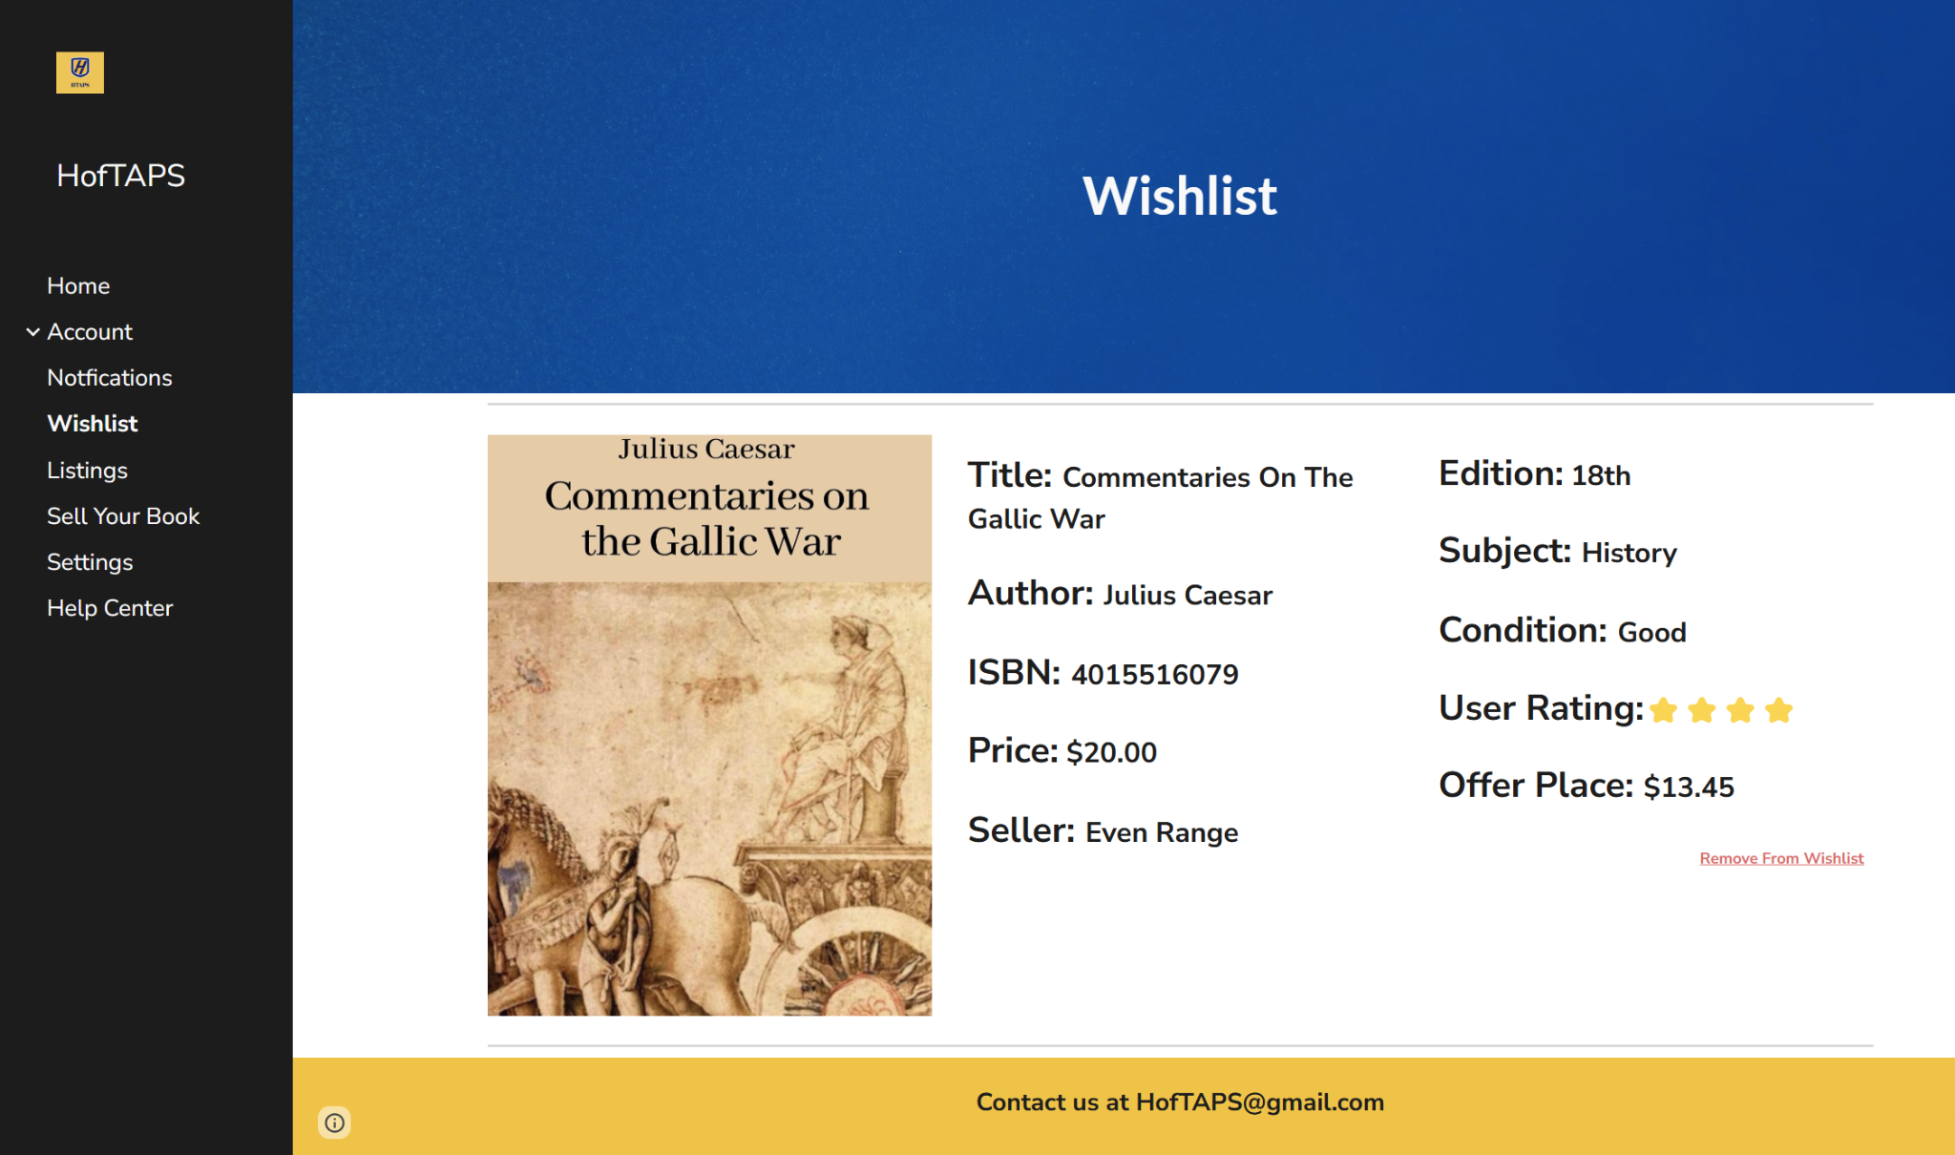

1.4.6 Listings

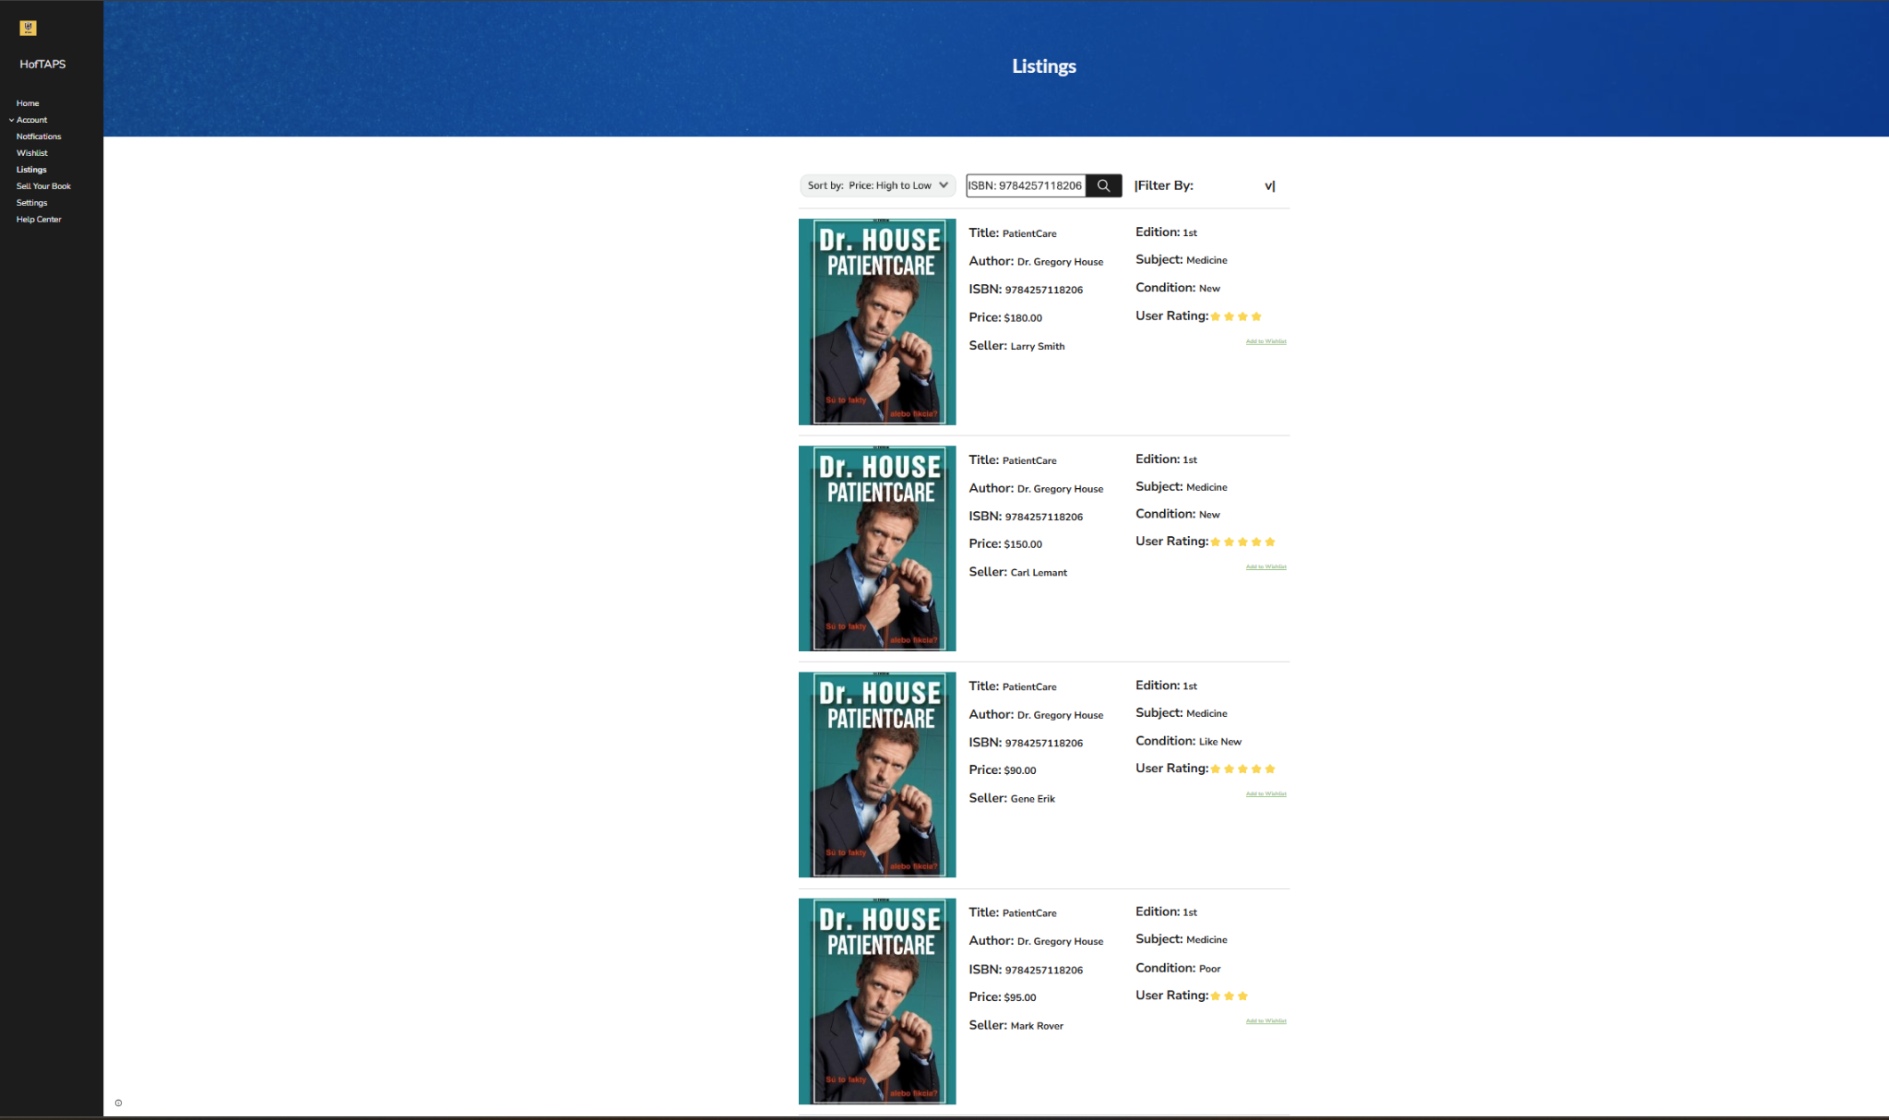

1.4.7 Individual Listings

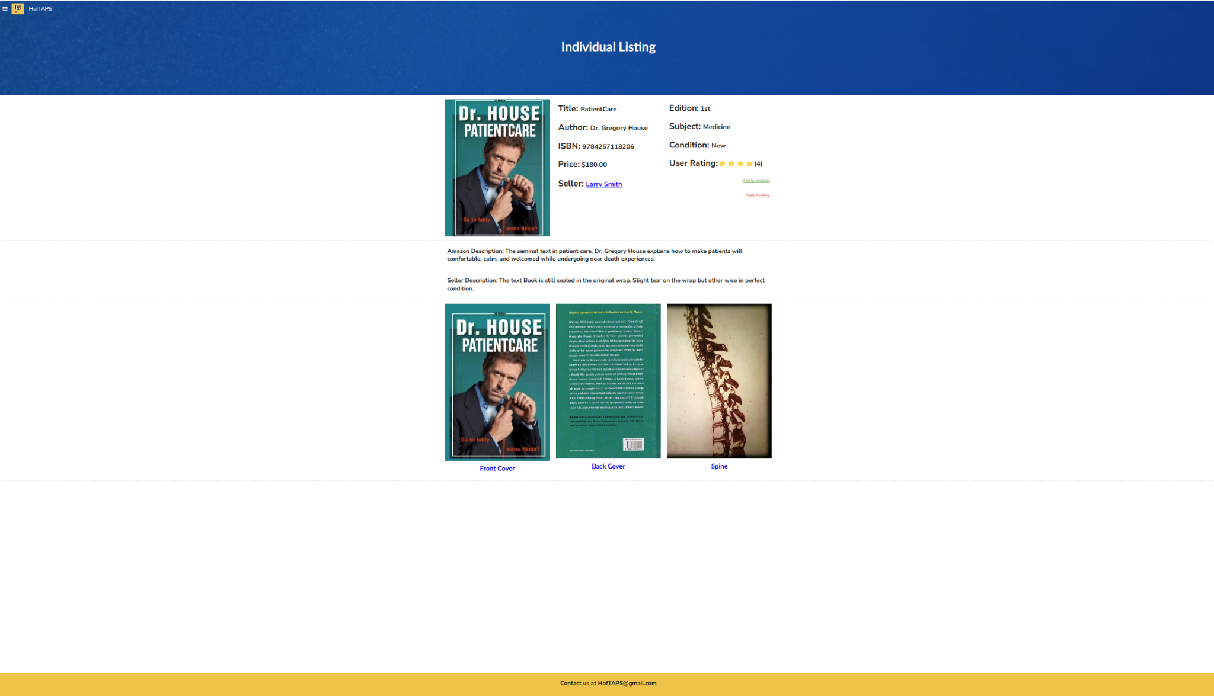

1.4.8 Sell Your Book

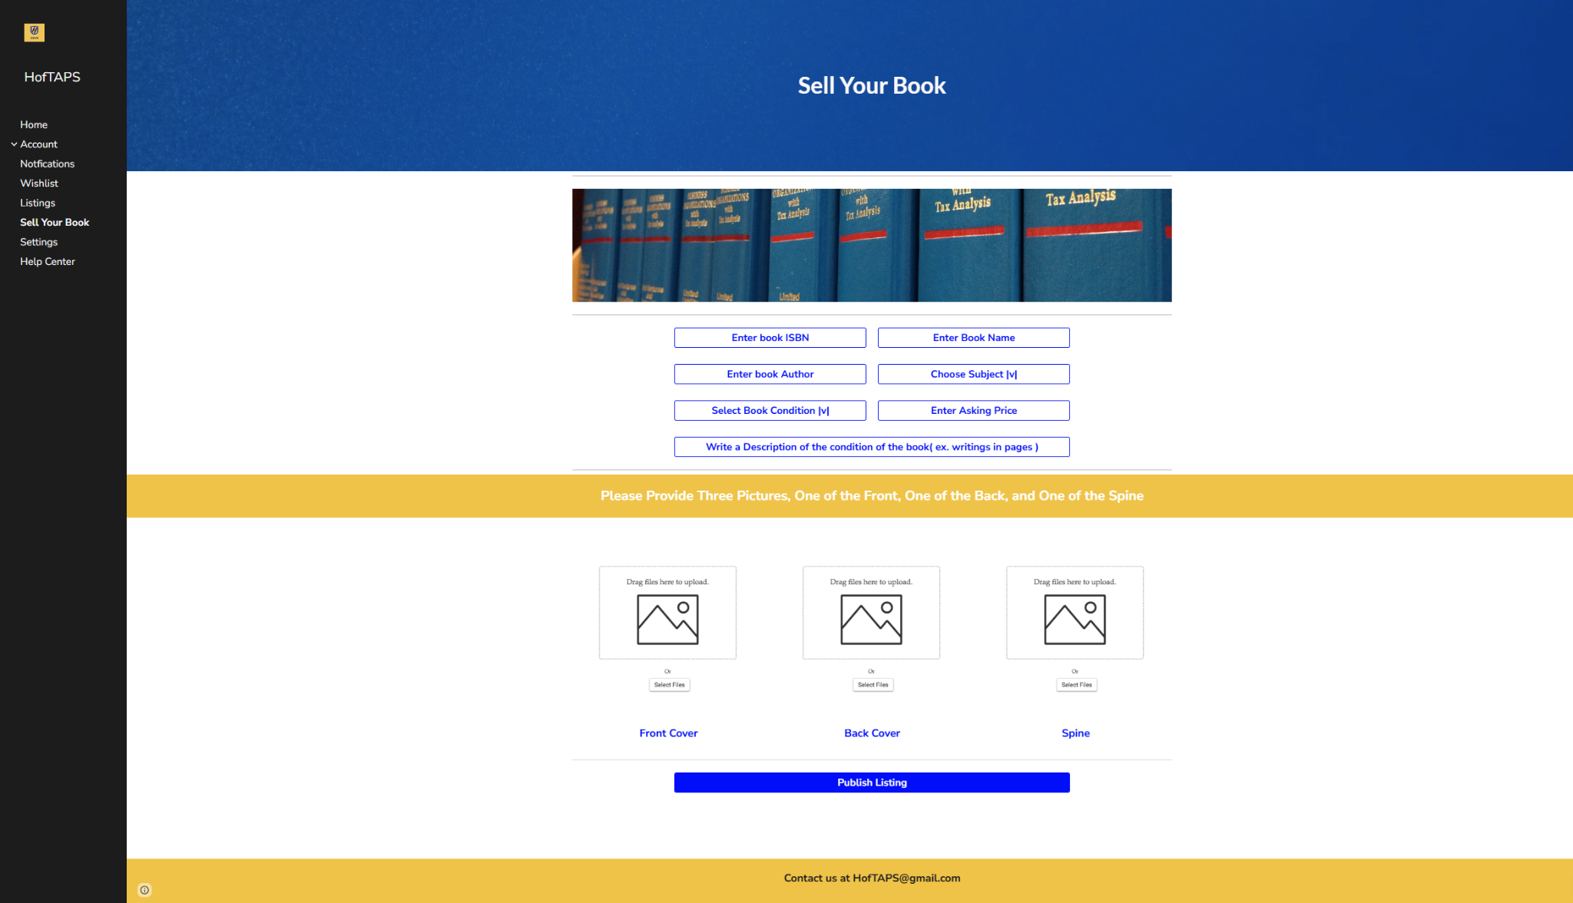

1.4.9 Settings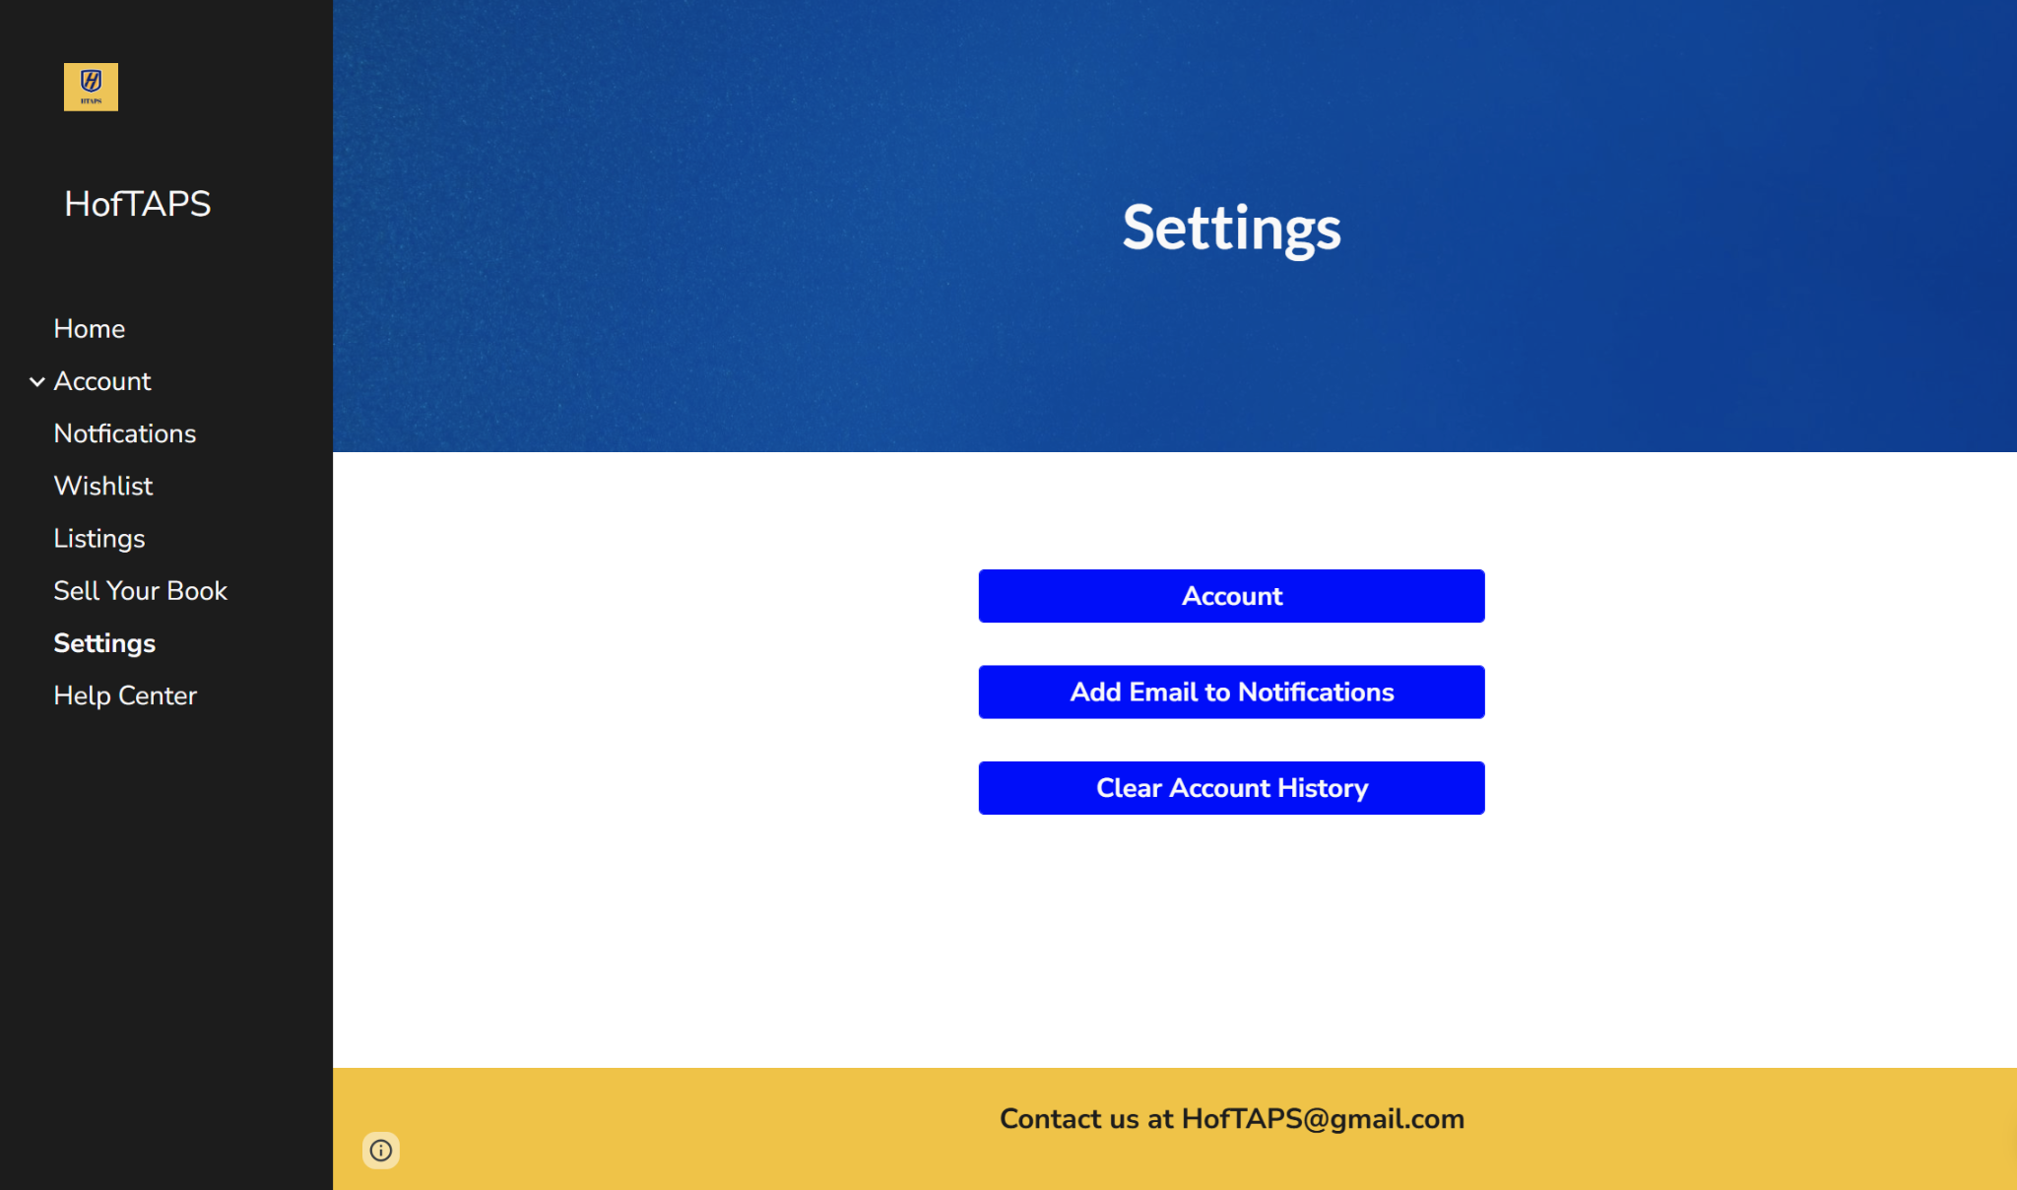

1.4.10 Create Account

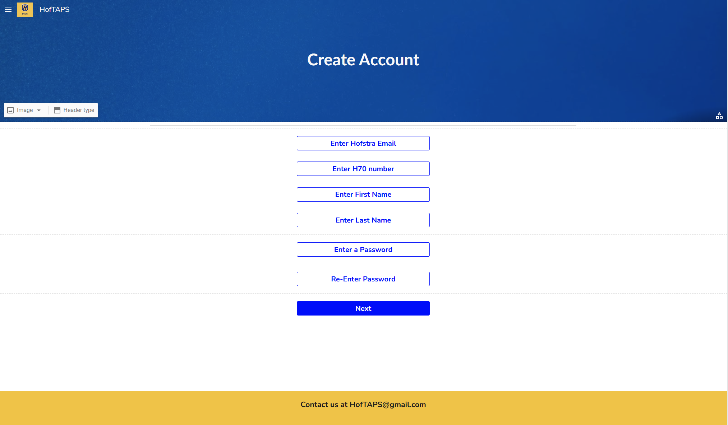

1.4.11 Create Account Verification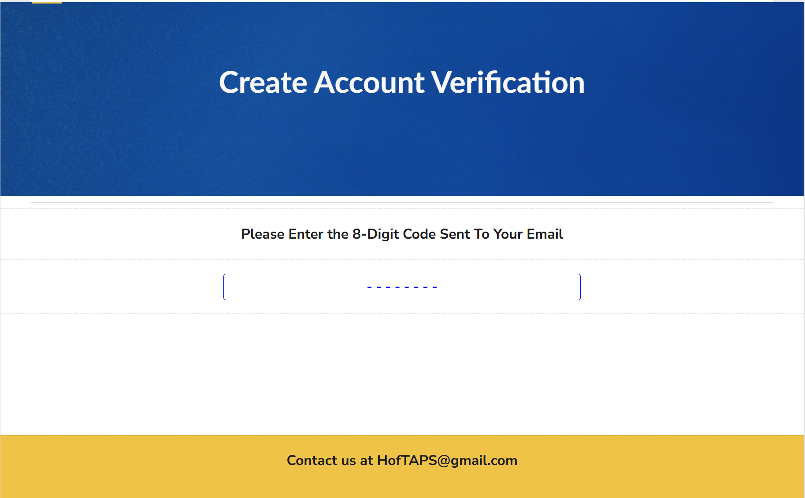

1.4.12 User Profile

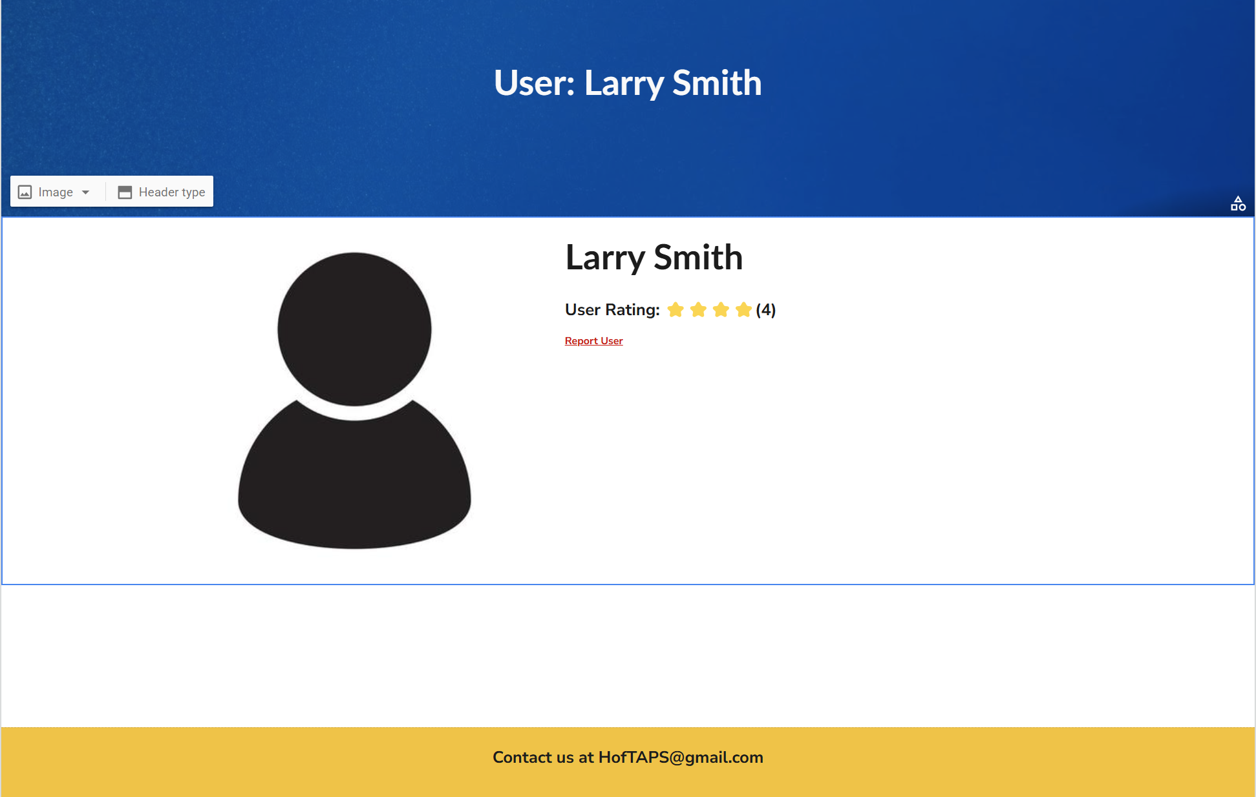

**2. Product Description**

**2.1 Description**

Jump into a dedicated textbook exchange for Hofstra students, this streamlined application allows a student with a textbook to connect with students who need a textbook, making for a cheaper, taxfree, and easier experience for both buyer and seller. The homepage makes actions clear and concise with search functionality that allows for multiple ways to search for that perfect textbook, as well as a carousel of textbooks that are hot on the market right now. Listings are easy to see and follow. When a seller accepts a buyer's offer, the listing is removed from the Listings Page in real-time. Listings can also be sorted in multiple different ways such as high to low price and by new listings. They can also be filtered by price, condition, and subject. If a user wishes to sell a textbook, the integrated Amazon API allows the seller to type in the ISBN while the website can handle the author, name, edition, and general description, making selling a breeze. Creating an account is simple and limited to only people with a Hofstra email, ensuring a closed and safe environment for buyer and seller. The Wishlist allows for the user to keep track of those textbooks that they need in a simple place, while the notification center allows for the users to see up to date information about the books that they are buying and selling. Our User Rating System allows users to see who is trustworthy and who is not. Once a seller accepts a buyer's price, the buyer confirms the sale and both buyer and seller are left satisfied.

**2.2 Features**

2.2.1 Search and Filters: Our search allows the users to search either by ISBN, author, or title.

They can also filter their results by condition, price, and subject.

2.2.2 Wishlist: A user can add listings to their wish list with a click of a button and have all the

textbooks they need in one place.

2.2.3 Notifications: Users have a real-time notification center to see if a seller has accepted or

rejected an offer, if a buyer has placed an offer, or if a textbook that you are interested in has been sold.

2.2.4 Textbook Carousel: On the homepage, users see a carousel of recently sold textbooks,

which is tracked by how many listings of a certain ISBN haven been closed recently.

2.2.5 User Ratings: Users give other users ratings based on their interactions. On the user

profile, it shows their rating out of 5 stars and how many people rated them. Ratings are an average of the rating a user receives.

**2.3 Operating Environment**

HofTAPS is designed to work on both desktops and mobile devices using browsers including Chromium based browsers like Chrome, Firefox, and Edge, as well as Safari. An internet connection or a mobile network is required to access the website.

**2.4 Design**

Every user is able to buy and sell as well as have their own unique wishlist and account history. When selling, the users indicate the subject of the textbook from a drop down menu, which allows buyers to easily look for which textbooks they want. The exchange of money takes place completely off platform, so no calculations need to be performed by the website. Notifications allow buyers to find out if their offer has been accepted and where they can accept.

**2.5 Constraints and Challenges**

One of the biggest challenges is knowing when to remove a listing from the database. In the application, the listing is removed whenever the seller accepts a buyer's offer. This means that in a scenario where the deal falls through off platform, the seller would have to relist the textbook again. There are also rate limits on Amazon’s API which affects the ability to gather information about the book such as the Amazon description.

**3. System Features**

**3.1 Main Page**

The system features of the HofTAPS homepage are designed for a user-friendly experience by facilitating the navigation of the website.

3.1.1 Search Bar: The search bar featured in the center of the main page has three central

components: searching by subject, condition of the textbook, and price. The search engine is extremely polished, providing users with the best results for what they are looking for.

3.1.1.1 Search by Subject: The subject and condition settings have a drop down menu

where there are multiple options based on the user’s preferences. The subject filter has general subjects like math, science, history, etc to narrow the search results.

3.1.1.2 Search by Condition: The condition setting has different options that show the

state of the quality of the book being sold. Options include but are not limited to, “New”, “Like New”, “Poor” and other terms to describe the condition of the book listed.

3.1.1.3 Search by Price: The price filter is a slider showing a limited range of prices to fit

the budget of the user. In addition to searching the textbook by name, the user can also type in the ISBN number to see the exact textbook they are looking for.

3.1.2 Sell Button: The sell button is shown on the center of the main page right below the

search function. It redirects users to an interior page where the user can post listings for any textbook they want to sell. This button is highlighted in blue so it stands out among other features on the home page.

3.1.3 Featured Items: Featured Items are provided below the search function

and the sell button. This section allows the user to browse through the image carousel of the featured books. If they are interested in looking even further into it, they can click on the image and are redirected to the book listing. There are always 3 featured books posted at a time based on popularity metrics on the site, which showcase which books are being looked at more often during that time.

3.1.4 Left Bar: The left bar on the upper left corner of the main page has an intuitive design,

including a menu listing important sections of the website.

3.1.4.1 Home Button: The home button brings the user back to the home page.

3.1.4.2 Account Button: Right below the home button is the account button, which

prompts users to their account page. If you click on the arrow next to the account button, a drop down menu is revealed providing additional resources related to having an account on this site. These drop down options are ‘create an account’, ‘login’, and ‘account history’. They redirect the user to the respective pages. The ‘account history’ button redirects users to a history of bought or sold textbooks and shows analytics such as how much was spent on textbooks.

3.1.4.3 Notifications: Below the account button, there is a notification button. When

clicked on, it shows any notifications a user might have received.

3.1.4.4 Wishlist: The Wishlist button redirects users to a list of textbooks that they added

to their wishlist. Users add books to their Wishlist by clicking a star icon on the textbook listing.

3.1.4.5 Listings: The listing button brings users to a more detailed textbook search page.

Users are provided with all the filters and search functions necessary, as well as the ability to view different listings posted by sellers.

3.1.4.6 Sell Your Book: Below the listing button feature is a sell button, which redirects

the user to the ‘sell’ page. This sell button provides the same function as the other sell button in the center of the home page, but both are added for convenience.

3.1.4.7 Settings: The settings button brings the user to a page where they can change

their account information.

3.1.4.8 Help Center: The help center button redirects users to a page where additional

contact information is provided, including contact info for website support agents.

3.1.5 Contact Information: At the very bottom and center of the main page, there is a Contact

Us section that includes text contact information in case of any questions or concerns. More information regarding contact details can be found in the help center page.

**3.2 Listing Pages**

3.2.1 Search Bar: The search bar is the center focus of the website. When loading the

webpage, it is located at the center of the page. When browsing through books, the search bar is at the top of the page.

3.2.2 Left Bar: The left bar of the webpage holds multiple options related to the user’s account.

They can choose to buy items, sell items from their account, can check their history of purchased books, and can manage their account’s settings.

3.2.3 Filters: When searching for a book, a user can filter the options that appear through

various qualities. They can filter books by subject, price, or condition.

3.2.3.1 Subject: When searching for a book, a user can filter results to show only

textbooks of a particular subject.

3.2.3.2 Price Slider: The filter for price comes with a slider that can be

used to select what price range a user is looking for.

3.2.3.3 Condition: The user can choose to only see books that meet a

particular condition requirement.

3.2.4 Sort: Sorting changes the way items are displayed on the page. They can be sorted from:

* Highest price to lowest price
* Lowest price to highest price
* Names from A-Z
* Names from Z-A
* Date uploaded from oldest to newest
* Date uploaded from newest to oldest

3.2.5 Individual Listings on Listing Page: Once a user finds their textbook, they

can click on it to bring them to the individual listing. This is where the user can see detailed information about the textbook and the seller, and where they can purchase the book.

**3.3 Selling Page**

3.3.1 Fields: When one sells a book, they must type its information for sellers. They must

provide the book’s:

* ISBN Number
* Title
* Author
* Edition
* Price
* Subject
* Description (Optional)

3.3.2 Image Uploads: A user must upload three pictures of the textbook they are selling. They

must provide a picture of the front, the back, and the spine of the textbook.

3.3.3 Publish: When a user clicks publish, the textbook is added into the database and appears

online for other users to find and purchase.

**3.4 Individual Product Information**

3.4.1 Layout: When a user sees a textbook they wish to purchase, clicking on the image will

bring them to the product page. This shows the icon of the textbook and other information shown on the listing page, including the title, author, ISBN, and condition, all of which are listed to the right of the cover. The user can also see the name and rating of the seller and the images of the textbook that the seller uploaded. There is a button below the textbook information that allows the user to purchase the textbook.

3.4.2 Contact Seller: When a user wishes to purchase a book, clicking on the purchase button

will automatically contact the seller that someone is interested.

**3.5 Purchasing**

3.5.1 Contact between Buyer and Seller: Purchasing a book automatically notifies the seller via

email and an in-site notification. These will redirect the seller to the website, where they can approve the sale or cancel.

3.5.2 Completed Deals: Once a sale has been approved by the seller, the sale is closed and

the textbook is removed from the listing.

3.5.3 Deals that Fall Through: If a seller rejects a sale or if the seller and buyer do not complete

the deal within 7 days, the book is automatically removed from the database and it must be added again should the seller still wish to sell the book.

3.5.4 Database Updates: The database holding the textbooks will update accordingly to not

only hold books that are available for purchase, but to also remove items that are already purchased, as well as to remove items that are no longer available. When a book is purchased, the confirmation the seller gives will remove it from the database so that it does not take up additional space. In addition, the 7 day period that checks for a confirmation ensures that if the seller is inactive, the book gets taken down and automatically removed from the database so that a user doesn’t end up being misled by a listing that is not actually available to them.

**3.6 Accounts**

3.6.1 Authentication: ​​Once a user creates an account, their email is validated via a unique

validation code sent to their email on their personal device, which is then entered in the provided space on the website.

3.6.2 Registration and Login: Users enter their full name, Hofstra email address, Hofstra

student ID, and a password to create an account. Their email is validated and their password is checked for security strength. Users can then login using their Hofstra ID and their password. All user information is encrypted.

3.6.3 Change Password: If a user forgets their password or if they wish to change it, they can

click the “Forgot Password” link on the login page, which directs users to the change password form. The user enters their email, then a reset password prompt is sent to their email with a link to reset their password.

3.6.4 Account Details

3.6.4.1 Personal Information: Each user account includes a user’s full name and Hofstra

email and ID number.

3.6.4.2 Account Management: Users can change their password and they can add

security questions for added safety measures.

3.6.4.3 Notification Settings: Users can opt to turn on or off email notifications

3.6.4.4 My Listings: All of the textbooks listed by the user are seen here. They can see

currently listed books, other users who are interested in their textbooks, and books they have previously sold.

3.6.4.5 Items Sold: Users can see all of the textbooks they have previously sold, what

price they sold it for, and who purchased their book.

3.6.5 Ratings: Ratings for individual books are fetched from the Amazon API. Users can also

rate other users based on their purchasing/selling experience out of 5 stars. These ratings are visible under user’s profiles.

**3.7 Notifications**

When a buyer wants to purchase a textbook, the seller receives a notification in their

notification center in-site, as well as in their email. Buyers and sellers also receive notifications when a sale is completed or canceled.

**3.8 Help Center**

3.8.1 Getting Started: Provides the user with an overview of how the platform works, as well as

instructions on how to create an account, list a book, and purchase a textbook.

3.8.2 Contact Support: Emails of support agents are provided to the users if they have any

questions or need technical support

**3.9 Searching**

3.9.1 Search Engine: Searching will be optimized via a third-party search engine. This engine

is customized to:

* Ensure typo tolerance and spellcheck
* Incorporate autocomplete suggestions
* Product attribute filtering
* Prioritize products listing based on popularity

3.9.2 Natural Language Processing: Allows users to search using Natural Language phrases

instead of just keywords.

**4. Interface Requirements**

**4.1 Live Updating**

Through the use of APIs, the application will update textbook information real-time. Textbook

availability is also updated real-time as books are listed and sold.

**4.2 Page Responsiveness**

4.2.1 Fluid Grid Layout: Percentages and grid systems allow elements to scale and

dynamically adjust column layout proportionally with screen size.

4.2.2 Breakpoints: Define specific screen size thresholds where the layout adjusts significantly

4.2.3 Content Prioritization: Ensure critical information and features are visible and easily

accessible.

**4.3 Categories and Search Filters**

Users can search for a book by name, subject, or ISBN. Book searches can be filtered by subject, price, and condition.

**4.4 Notifications**

A seller receives a notification when an interested buyer has purchased one of their listed textbooks. The buyer is notified when the seller has approved the purchase. The buyer is also be notified if the seller decides to cancel their order

**5. Non-Functional Requirements**

**5.1 Efficiency**

5.1.1 Item Search Time: The interaction between the website requests and the API takes no

more than three seconds, allowing for a more efficient user experience.

5.1.2 User Database: The website is able to accommodate at least 1,000 new user data

simultaneously without overloading the database or degrading website functionality.

5.1.3 Page Loading Time: The user interface takes about 2-3 seconds of loading time to

display textbooks retrieved by the API as well as between each page that the user navigates to under standard network conventions (10 Mbps or above).

5.1.4 Search Filters: The user can apply filters to their search to efficiently find their desired

textbook.

5.1.5 API Retrieval: The API is able to handle at least 1,000 requests per minute

**5.2 Usability**

5.2.1 User Interaction with the Website: The user must be able to navigate the website with

ease. Therefore, widgets and displays are being kept in an organized, user-friendly manner to ensure efficiency and performance.

5.2.2 Cross-Platform: Users are able to access the website on both mobile and desktop

platforms, ensuring full functionality of all features.

**5.3 Space**

The account information is stored into a secured database. It is determined that 512 MB is sufficient to handle at least 1000 user data.

**5.4 Dependability**

5.4.1 Error Handling: The website displays appropriate error messages to provide users

information for debugging

5.4.2 Website Runtime: The website is in operation 99.9% of the time

**5.5 Security**

5.5.1 Password Encryption: User account sign in information is encrypted to ensure

confidentiality. The user is required to input username and password in which only the password is only knowledgeable to the user.

5.5.2 Notification Encryption: The website messaging system keeps all the notifications

encrypted that may contain sensitive information.

5.5.3 User Encryption: Details regarding account information, date of birth, order numbers,

payment information, etc. is identified and set as privileged information that will be encrypted and only accessed by authorized personnel.

5.5.4 Captcha: The website implements a captcha protocol to prevent users from deploying

automatic bot attacks at the website

**5.6 Maintainability**

5.6.1 Code Quality: The website structure code is written in a way such that the software is

scalable, allowing the admin to make modifications with ease. This includes using well-structured code using relatively similar naming functions

5.6.2 Scalability: The website is able to support new addition of textbook information with

relative ease without any significant changes to structure code

**5.7 Data Accuracy**

All information regarding textbook details (i.e. ISBN, publisher, author etc.) is updated regularly.

**6. Conclusion**

HofTAPS is a modern and efficient web-based application in which students attending Hofstra University are able to efficiently locate and purchase affordable textbook options for their classes. In its entirety, HofTAPS aims to be a leading platform amongst other textbook-selling platforms and increase more freedom for users rather than restricting them to limited buying and selling options; the platform fosters an open marketplace where students can freely negotiate prices, communicate directly with sellers, and explore multiple purchasing methods to find the best deals. By prioritizing user autonomy, HofTAPS ensures a more dynamic textbook exchange experience. In addition, HofTAPS serves as a demonstration that other students may be able to implement in order to find and purchase textbooks within their college community. HofTAPS uses state-of-the-art databases alongside cybersecurity protocols like MongoDB. In addition, the website encourages users to communicate with each other through our integrated messaging system, allowing direct communication between users to encourage sales. HofTAPS is maintained, updated, and tested regularly for a more simple yet productive experience so that users may be able to make productive sales by selling old textbooks and/or finding textbooks for class to ensure academic prosperity.